Software Engineering G6046
Group Coursework Team Review Meeting
The purpose of this meeting is:
- To review progress.
- Ensure that any issues with the team are identified.
- Ensure that the team understand what they need to do to complete the work.
- Have a definite plan about how to complete the work.
This meeting does not form part of the assessment but will form a written record that the teaching delivery team may refer to later when assessing team performance.
Team | 22
Present | Adarsh, Gunbir, Johnson, Oscar, Tevy
Review by | Adarsh, Gunbir
Date | 13th March 2025

Quick checklist
How many sprints have you completed? | 2
Have the sprints delivered a working prototype? (one from each sprint) | Yes, working prototypes were delivered at the end of each sprint so far.
How many active members are in your team? | 6 (All members have been active in the team)
How many inactive members are in your team? | 0

Q1: What planning have you undertaken so far? (PERT/Risk/resources etc)
Risk Analysis and Management:
We have created a Risk Analysis document to identify 10 potential risks that could derail our project’s progress and planned mitigation strategies for each of them. In this document, we have outlined the impact each of these risks would have, their likelihood of occurring as well as ways in which could monitor our work to help mitigate these inherent risks.

Gantt Chart:
We are making a small Gantt chart for each sprint to monitor individual tasks on a bi-weekly basis.

PERT Chart:
We are also planning on making a PERT chart for the overall project that will help monitor the progress of larger groups of tasks that might span across multiple sprints.

Team Meetings:
We hold regular team meetings to review our progress, address any issues that we may have encountered and plan what tasks we want to complete next for the project.

Q2: Have you been monitoring the Canvas discussion threads for updates from your customer?
Yes, we have been actively monitoring the Canvas discussion threads for updates and clarifications from our customer, Watson Games.

Q3: What languages and tools have you selected for your implementation?
We are implementing our project in Unity; therefore, the programming language we have primarily used is C#. We also used Blender to design some of the assets in the game such as the dice and the tokens being used by the players. We are using GitHub to store an active repository of the project, allowing us to collaborate on code simultaneously and track changes made by each individual. All other non-coding files are shared via OneDrive and the entire project is saved onto OneDrive every 2 weeks as a back-up in parallel to the GitHub repository.

Q4: Is there a current working prototype? If so, show it (use screenshots if filling this in offline).
Yes, we have a current working prototype. The following screenshots were at the beginning of the 3rd sprint:
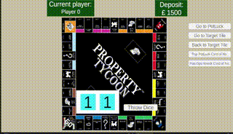

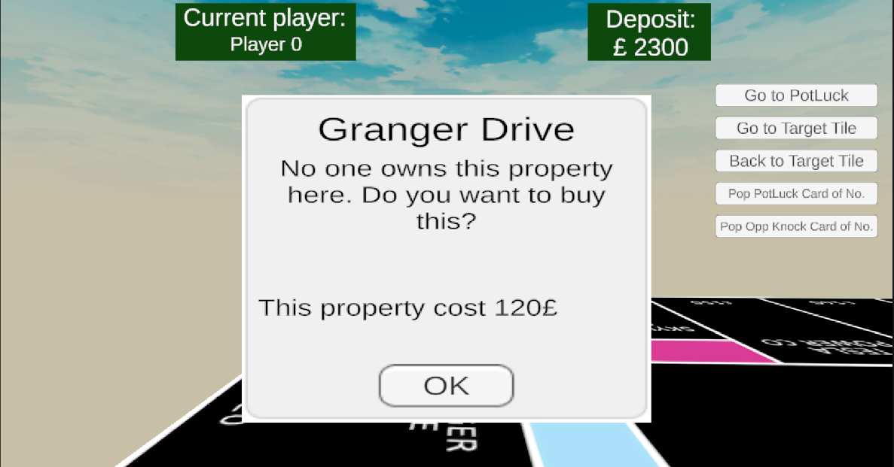

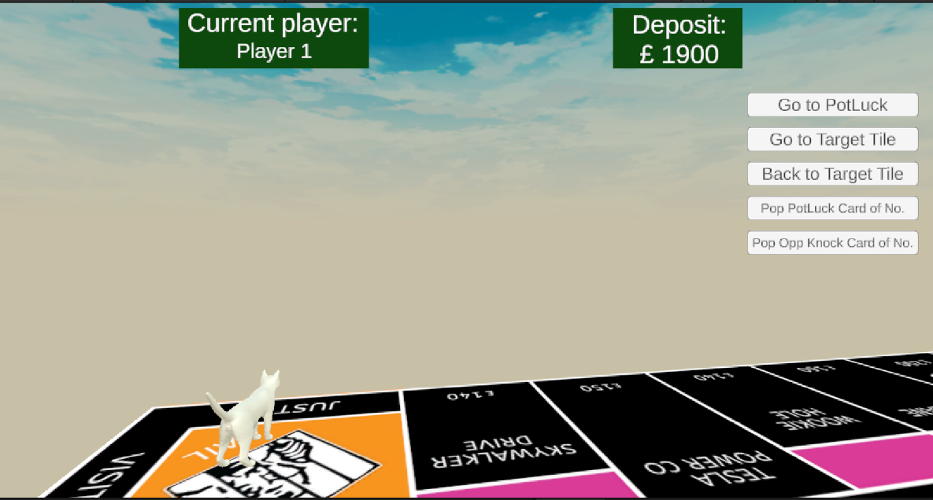

Q5: Are there any kind of other demonstrable elements yet? For example, visualisation mock-ups, class diagrams?
Yes, we have developed several demonstrable elements for the project. During the initial stages of development, we created visualisation mock-ups to outline our vision for various aspects of the game’s user interface and design. For example, we produced rough sketches for how we wanted the UI of the main menu, game board and individual tiles to look like, so we could establish a clear design direction. This helped us better understand the project’s structure and user experience. Furthermore, we have begun working on a class diagram to map out our project’s architecture, but unfortunately, it is not yet complete.

Q6: Is there anything you need feedback for from your customer?
No, we do not require any specific feedback from Watson games at the moment.

Q7: Are there any other factors that are having an effect of your team’s ability to deliver on this group project?
The biggest challenge for most team members has been balancing this group project alongside their other academic commitments, including assignments and exams for other modules. Notably, half of the team, who are enrolled in Game Development modules, have had to manage and deliver four projects simultaneously this semester. This can be overwhelming at times and hinder the progress of these projects.

March 2024

